“The Sun Never Sets”
Version II
ADVANCED Rules & Notes (version 2c ©2017 Outside the Cube)

Welcome to The SUN NEVER SETS – VERSION II; The game of Diplomacy, Quest, and Conquest. Pitted against others, you vie to acquire land and ultimately control the world of DAVEN (Dah-Ven). You can choose to use your diplomatic skills and build a strong alliance or rather, train and build a massive army capable of crushing your opponents forces; Either way, it’s totally up to you… and a little luck* of course. So, read the rules, grab a BEvERage, re- read the rules, and let the fun begin. It’s time for a new world order - will it be you?

NOTE: After you read the rules, be sure to read the Game Master (GM) Guidelines & Assumptions section in Appendix B. There are extensive hints, comments, and suggestions about the game, game-play and Game Master-Player/Player-Player interaction.

Some appendices have been created BUT will be for GM eyes only. This will allow minimal GM leverage/favoritism to game play AND maintain a GM set of guidelines.

* “Luck is what happens when preparation meets opportunity.” (1993. FUBARS est.’89)
FOREWORD

This game is a result of Dave’s never ending search for ways to keep his mind occupied. Not satisfied just playing the games or reading the books, Dave has to find a way to take it to the next level. He needs to try his own hand at it. And once that wonderfully warped mind of his sets out to do something, there’s no stopping him.

This is the second version of The Sun Never Sets. One time is never enough, so here we go again. We can always strive to make things a little better. These reworked game instructions represent Dave’s second go at it. He has eliminated some things, added others, and modified some of the Pre-existing rules. On the game master side, he has come up with an automated method of validating player moves. The result hopefully will be faster turnaround times.

Of course, what good is a game if no one ever plays it? That’s where the rest of us come in. Jay, Paul, Jeff, Eric, and Mark did the beta testing for the first version of the game. Now we have even more players to put this new and improved version through its paces. Who’s going to end up victorious this time around? Only the gods know. The rest of us will just have to wait to find out.

So let the game begin!

Mark A.
Former Ruler of the Empire of Angmar
(Winner of the first evolution of TSNS)

CONTENTS
I. TURNS 1
II. CURRENCY 1
III. LANDS 2
IV. Units 4
RULE CLARIFICATION 5
V. BATTLES 9
Battle 9
Battle Initiative 10
Battle Resolutions (B.V.R.) 11
VI. SIEGE RULES 14
VII. HEROES, DRAGONS, AND WIZARDS 15
VIII. DIPLOMACY 16
IX. LEADERS, ASSASSINATIONS, AND WINNING THE GAME 17
Appendix A 18
Table A. Unit/Structure Cost and Upkeep 18
Table B. Battle Initiative for more than three players entering a hex. 19
Table(s) F. Fate Rolls and Results 20
Table F.a. Land Fate Rolls 20
Table F.b. Hero/Dragon/Wizard Fate Roll (Losing Battle) 21
Table F.c./F.d Special Unit Abilities & Fate Rolls 22
Appendix B (GM/Player Guidelines & Assumptions) 23
Appendix C Hero Profiles 26
Lord Alphan 26
Gammane 27
Epsone 28
Lord Zetar 28
Etam 29
Thetam 29
Iotane 30
Lady Kappan 30
Lamdaw 31
Noble Omegan 31
Appendix D Dragon Profiles 32
BLACK Dragon 32
RED Dragon 32
BLUE Dragon 33
GREEN Dragon 33
WHITE Dragon 34
BRONZE Dragon 34
GOLD (Yellow) Dragon 35
SILVER (White) Dragon 35
Appendix E Wizard’s Council 36
Appendix F . LEGACY Weapon Profiles 40
Appendix Z (Reference Materials) 41
Castle building 52
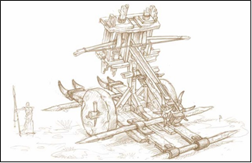
Welcome to The Sun Never Sets. here’s what you need to know –

I. TURNS –

A. Turns are due to the GM, via e-mail, by the date designated by the GM and each “Turn” will account for 1 month of your empires life (1 turn=1 month; 12 turns=1 year; Turns will not necessarily coincide with our actual human calendars!)

B. Turn Order - Turns will be played by the GM in the following order –
Fate
Movement/Fate (if necessary)
Battle/Battle Resolution
Builds/Upgrades
Money
Special Events

II. CURRENCY – kWAN “k”

A. Primary Source -
- Lands - subject to “events” (Fate Rolls) – Fate Rolls* are a 5% probability per month (a roll of 96+ results in either a penalty or reward “event.”)

* FATE ROLLS are located in Appendix A. Table F.a.

B. Alternate Sources -
- Bonuses – Awarded (where/if applicable) for Quests, Goals, Pre-set by GM, etc.

NOTE: ANY remaining kWan (if APPLICABLE) will be awarded to the player that claims another players final hex!

III. LANDS -

A. 1 Hex = 1 Land (for purposes of this document “Lands” or “Hexes” are the same)
1 Land/Hex yields 85-125 “k” kWan/Turn (seasonal)

Land/Hex Yield/Upkeep will have the following schedule -
Aug/Sept/Oct (FALL) - 125 "k"/Turn less 0 "k" upkeep
Nov/Dec/Jan (WINTER) - 125 "k"/Turn less 25 "k" upkeep
Feb/Mar/Apr (SPRING) - 125 "k" Turn less 35 "k" upkeep
May/Jun/Jul (SUMMER) - 125 "k" Turn less 25 "k" upkeep

All of the Hexes a player owns will form their empire.

B. Ownership –

To “own” a hex a player must simply stop any Unit in a hex and “Claim” that hex for their empire. If a Player does not wish to “Claim” a hex, they may travel freely through them. If the hex is owned by another player, then the player(s) entering will “Attack” (battle) the hex.
NOTE: Player’s may buy, sell and trade hexes. All negotiations go through the GM.

Lands adjacent* to mountainous terrain “MAY” receive a “mining bonus”

C. Movement –

All Units move simultaneously at a rate of up to 2 hexes/turn unless otherwise noted. Move orders must include all hexes and once a Unit Stops (either to finish its turn and/or battle/claim a hex OR upgrade) it cannot move again until the next turn.
(E.g. 5 Knight Units – 1209-1310-1310)

Unit orders will be limited to 20 Orders/Turn

Passing – “Allied” players may allow their teammates to “pass” (traverse) through each other’s hexes HOWEVER the player passing must complete their turn on their OWN hex OR claim it as their own. (Players may agree to “claim” hexes to facilitate movement.).

NOTE: If any traversing Units are located within an allied player’s hex, should that hex be attacked during movement then combat will be governed as per Section V.B.3. More than two players entering a hex but two or more players have an alliance

OPPOSING/PASSING UNITS WILL NOT BATTLE

If two opposing players move through a hex to attack/claim another hex, they WILL NOT battle in the middle unclaimed hex as was the previous method in TSNS I. This will speed up turn processing.

D. Tunnels & Bridges –

A player may “claim” a numbered hex with a tunnel (completely within mountainous terrain) or bridge (completely within water terrain) depicted on it. Basically if the hex has a number on it, you can own it!

E. Structures & Castles & Max Structure Limits –

A player may elect to build Structures for Unit Evolution upon their hexes. The following is the evolution of structures and their MAX Swordsmen Unit builds* –

Stage 1 Tower/Toll
Max Swordsman Unit Build – 25
Max # of Towers/Player = 10

Stage 2 Keep (Walled) (Requires 1 Siege Tower** to attack)
Max Swordsman Unit Build – 50
Max # of Keeps/Player = 5

Stage 3 Fortress (Walled) (Requires 2 Siege Towers** to attack)
Max Swordsman Unit Build – 100
Max # of Fortresses/Player = 2

Stage 4 Castle (Walled) (Requires 3 Siege Towers** to attack)
Max Swordsman Unit Build – 200
Max # of Castles/Player = 1

* - There is NO LIMIT on Unit Upgrades for ANY Structure.
** - a DRAGON may replace the requirement of ONE Siege Tower in battle

IV. Units -

1 Unit = 10 men* (This is for future play purposes)

A. Training of Troops and Training Evolution -

All Units require Training! Training will take 1 Turn per evolution and costs a fee per Unit of men trained. A player will train men from their General Population (Gen. Pop.) First buying them to be Swordsmen AND THEN training them into one of two distinct training programs (evolutions) which will yield either Infantry or Artillery Units.

NOTE: All Units MUST be trained/upgraded in a hex that contains an appropriately “rated” structure or “Walled” structure (owned by that player.)
NOTE: Swordsmen may be built at ANY “Structure.”

B. Evolution –

After purchasing a unit; (1 Turn bought and paid for) men will emerge as a basic Swordsman (Lowest rank for the infantry and artillery evolutions.) Once a Swordsman, the player can then elect to “Upgrade” a Swordsman into either the INFANTRY evolution OR the ARTILLERY evolution. Keep in mind that once a Swordsman is trained into either evolution, they CANNOT be cross trained (although at any time, higher ranking Artillery Units may be reduced to Swordsman to begin training in the Infantry evolution, or vice versa - This must be annotated on the Orders Sheet.)

NOTE: All Units must be upgraded from the previous evolution; E.g. You cannot just buy a Cavalry Unit off the street (no mercs); you have to pay the training fee to “upgrade” an existing Long Swordsman Unit you have already. (NOTE: You will pay the build cost (ONE TIME FEE) and the new upkeep cost of the Unit immediately and it will be available upon your next turn.)

All Units must be located within the required build structure (if applicable) upon the turn in which they are to be upgraded – E.g. A Cavalry Unit not located within a hex containing a player’s Fortress (required structure for upgrading Cavalry to Heavy Cavalry Units), MUST move the Cavalry unit into that hex upon the turn in which the player wishes to upgrade that Unit to Heavy Cavalry.) Again, the upgrade MUST be annotated in the Orders Sheet.
NOTE: All Structures may upgrade Units of a lower evolution (E.g. All Unit types may be upgraded at a castle.)

RULE CLARIFICATION: Units MAY move to a structure and upgrade in the same turn However, Units MAY NOT upgrade and then move in the same turn. Upgrading ends their movement phase for that turn! ALSO - AT NO TIME may a UNIT be upgraded at a STRUCTURE being upgraded to the required build level in the same turn. (E.g. an Archer (B.R. I) MAY NOT upgrade to a Marksmen (B.R. II) in the same hex/turn that a Tower/Toll House (I) is being upgraded to a Keep (II).

The following tables show the Infantry and Artillery evolutions -
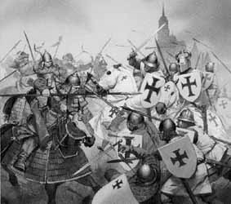

C. Infantry Evolution - The most versatile of the two programs, Units are trained (for a fee) in the following progression.

Unit | Move | Counter | Category | Combat Roll | B.R.*
Swordsman | 2 | S | Light Infantry | 1d4 | N/A
Long Swordsman | 2 | LS | Light Infantry | 2d6 | (I)
Cavalry | 2 | C | Medium Infantry | 3d8 | (II)
Heavy Cavalry | 2 | HC | Heavy Infantry | 4d10¹ | (III)
Knights | 2 | K | Heavy Infantry | 5d12¹+5 | (IV)
* B.R. (Build Requirement) = Structure required to build Unit.

¹ Heavy Cavalry Units get a +2 to ALL of their Combat Roll(s) upon land depicted as PLAINS.
¹ Knight Units get a +3 to ALL of their Combat Roll(s) upon land depicted as PLAINS.

All Infantry Units may only travel upon hexes depicted as Plains, Forest or Water/Mountainous terrain with a bridge/tunnel depicted on it. They may NOT travel upon water, or Mountainous terrain without a tunnel depicted on it.

NOTE: See Table A. Appendix A. for the cost, build time and upkeep of units & structures.

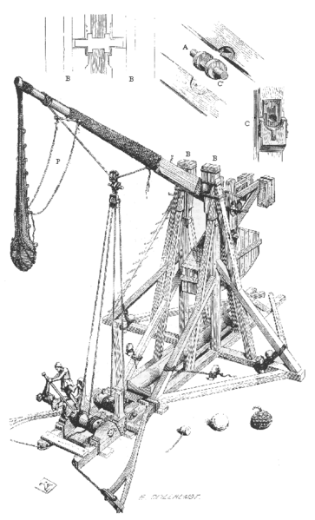

D. Artillery Evolution - Some of the more formidable Units are trained in the following progression however, while Artillery Units may receive generous attack benefits, they also suffer restrictive attack penalties and/or movement limitations depending on terrain type .

Unit | Move | Counter | Category | Combat Roll | B.R.*
Swordsman | 2 | S | Light Infantry | 1d4 | N/A
Archer | 2 | A | Light Artillery | 2d6 | I
Marksman | 2 | M | Light Artillery | 3d8 | (II)
Ballista¹ | 2 | B | Medium Artillery | 4d12 +2 | (III)
CaTapult² | 2 | T | Heavy Artillery | 5d20 +5 | (IV)
* B.R. (Build Requirement) = Structure required to build Unit.

¹ Ballista may NOT operate (attack/defend) within mountainous terrain including terrain with a tunnel located* in it however, a Ballista MAY travel through a tunnel.

² Catapults get +2 to ALL Combat Rolls from within any hex with a Walled Structure.
² Catapults may NOT operate (attack/defend) within Forested terrain; however they MAY travel through it.
² Catapults may NOT operate NOR travel through mountainous terrain including terrain with a tunnel located* in it.

* This does not include hexes at the mouth of a tunnel or bridge.

E. Cost –

Units will of course cost you kWan to train and maintain. In Appendix A; Table A. you will find the table for cost and upkeep for the Units in The Sun Never Sets.
(NOTE: If you are showing a deficit, GM will begin with lowest ranking units and remove any amount of units applicable to render as close to a zero balance as possible - NO EXCEPTIONS!)

F. Buying & Selling Units –

Players may NO LONGER buy/sell units however, providing money to another player for the purpose of buying units/upgrades is allowed!

Players may also sell/trade their hero/dragon/wizard and/or entire realm for an agreed price.

All transactions MUST go through the GM!

V. BATTLES
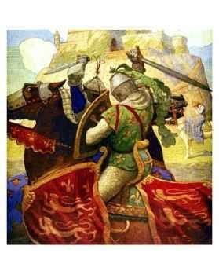
Battle –

If two or more players enter a hex (including instances in which a player already occupies the hex in which another player enters) battle will ensue (unless otherwise noted, e.g. both parties are of an alliance and/or both parties have a “free trade/claim” agreement and have NOTIFIED* the GM as such)

* Notification requires that BOTH players send the agreement to the GM, AND have an existing agreement set prior to entering each other’s lands. Any failure to notify the GM will result in a battle between players and loss of Units.

Player’s MAY NOT break an “alliance” and attack their former ally in the same turn. This may be ratified in a later rules set but for now, Player’s wishing to break an “alliance” MUST first announce the nullification of the alliance and attack in a subsequent turn.

All Unit dice rolls will be accomplished using WINDICE (Windows), DICESHAKER/DICENOMICON (iPhone) AND/OR equivalent auto-die rolling program. These programs allow the Game Master (GM) to roll impartial dice and add modifiers directly to roll results. (e.g. the GM may roll 24d12 for 6 Ballista Units AND add the +12 for automatic modifier)

NOTE: Any players wishing to attack a land that contains a Walled Structure must attack with the proper number of Siege Towers.

Battle Initiative –

1. Two players entering a hex -
If two players enter a hex on the same turn and battle ensues, neither player will gain an initiative modifier. Both army attack values will be calculated and resolved with the BATTLE Resolution Program (BRP.)

2. More than two players entering a hex –
If more than two players enter a hex on the same turn and battle ensues; The player with the higher number from a roll of a 1d20 will battle with the player with the lowest roll first. At the completion of that battle, BATTLE Victory RESOLUTION (BVR) will be calculated and the remaining Units will engage the player who rolled the next lowest roll…
(E.g. Player 1 rolls an 18, Player 2 rolls a 3, Player 3 rolls a 15; thus Player 1’s army will battle Player 2’s army first. At the completion of that battle and BVR has been calculated, the remaining Units of Player 1 or Player 2’s army will battle Player 3’s army and battle ensues as normal for Two players entering a hex.)

NOTE: For battles with more than three players entering a hex, see Appendix for battle tables -

3. More than two players entering a hex but two or more players have an alliance –
If more than two players enter a hex and two or more of the players are “allied”, then the two “allied” players will be grouped as one whole “Army” of Units and will count as ONE player for purposes of the tables. Thus allied Armies will/could be much stronger than single Armies. For BVR calculations in which the winner was the “allied” players, the win percentage of the TOTAL allied force will be applied to the winning armies of the alliance individually. Thus, if the winning allied Units of players 1 and 3 won by a percentage of say 60% for example; Both players 1 and 3 would lose 40% of their Units.

Note: Allied players MUST annotate which allied player will “Claim” the hex. The “unclaimed” ally MUST vacate the hex on the next turn!

4. Players entering a hex which contains a Structure: Tower -
When players enter a hex that contains a structure, battles ensue as normal unless the structure is either a Keep, Fortress or Castle -

5. Players entering a hex which contains a Walled Structure: Keep, Fortress or Castle -
If players enter a hex owned by a player that contains a Keep, Fortress or Castle then Siege Combat Rules are also considered. In order to engage a Walled Structure the opposing army MUST be accompanied by one, two or three Siege Towers for a Keep, Fortress or Castle, respectively. Any combination of Siege towers from two “allied” players, so long as they meet the minimum required, will be fine.

Battle Resolutions (B.V.R.) –

Obviously you cannot win a war without possibly, and more than likely, losing some Units so, the formula for victorious Unit kills is as follows (for all battles scenarios)
NOTE: A program is hopefully being developed to provide more accurate results to battles, until then, the following still applies.

The margin of victory of the winning army over the losing army will determine a number called the Battle Percentage Difference. This percentage will determine what number of the winning armies Units remain after the battle.

BATTLE Victory RESOLUTIONS (BVR) will be calculated using a Microsoft EXCEL® spreadsheet titled BVR_2012.xls (referred to as the BVR file.) The spreadsheet will round Units to the nearest whole automatically. (EXCEL rounds from .50 upward, thus there will be some margin of error.)

NOTE: All battle resolutions will be accomplished with the BVR file

NEW RULE - STRATEGY AFFECT!!!
The concept AND mindset behind battle has always been that swordsmen, long swordsmen, etc would be frontline troops, suffering the majority of casualties, with additional losses working backwards towards ballista and knights. (e.g. If an army won by 50% you would lose swordsmen, but you would not lose a ballista or knight! HOWEVER if you won by say a mere 10% well then, all bets are off.!?)

The NEW ATTRITION MATRIX for battle resolution...
The troops included in the BVR randomization will be as follows -
An Army that:
Wins by 75% OR MORE will sustain NO CASUATIES (no change)
Wins by 60% - 74% will sustain CASUALTIES to Swordsmen (S)
Wins by 45% - 59% will sustain RANDOM CASUALTIES to S, LS, A
Wins by 30% - 44% will sustain RANDOM CASUALTIES to S, LS, A, C, M
Wins by 16% - 29% will sustain RANDOM CASUALTIES to S, LS, A, C, M, HC, B
Wins by 15% OR LESS will sustain RANDOM CASUALTIES to ALL UNITS!
EXAMPLE NOTE!!!
After a battle, if the percentage you won by was 68% and the BVR dictates that the GM had to remove 13 UNITS and you went into battle with 5 Swordsmen and 25 Knights - REGARDLESS of unit type, 13 UNITS will have to die (Therefore you're Knights will not be exempt from attrition!) So plan your advances carefully and balance your forces!?...
Remember, an army that wins by 75% OR MORE will sustain NO CASUALTIES – This is the ROUT Rule!

BVR file notes –

NOTE: A Battle Percentage Difference of 75% or greater will result in NO LOSS of Units by the winning army.

The "BATTLE OF THERMOPYLAE" Rule -
After a defeat in battle you will be provided the information if a Hero, Dragon, Wizard and/or Legacy Weapon was involved in battle. The theory is that news of the battle would be reported home.

DRAGON COMBAT NOTES

- All Dragons have an attack of 5d10. If a dragon is engaged in a battle with an army that has NO artillery units, the dragon attack value WILL TRIPLE!

e.g. An army consisting of 25 Swordsmen AND a BLACK dragon is attacking an army with 25 Cavalry. The attacking army will roll 25d4 for the Swordsmen PLUS 25 for the Black Dragon Infantry Unit modifier PLUS 15d10 because the dragon is attacking an army with NO artillery units – AWESOME!

- A Dragon in a losing battle will roll the same fate roll as a hero in a losing battle – Table F.b. Hero Fate Roll (Losing Battle)

VI. SIEGE RULES – Attacking a HEX that contains a WALLED STRUCTURE.
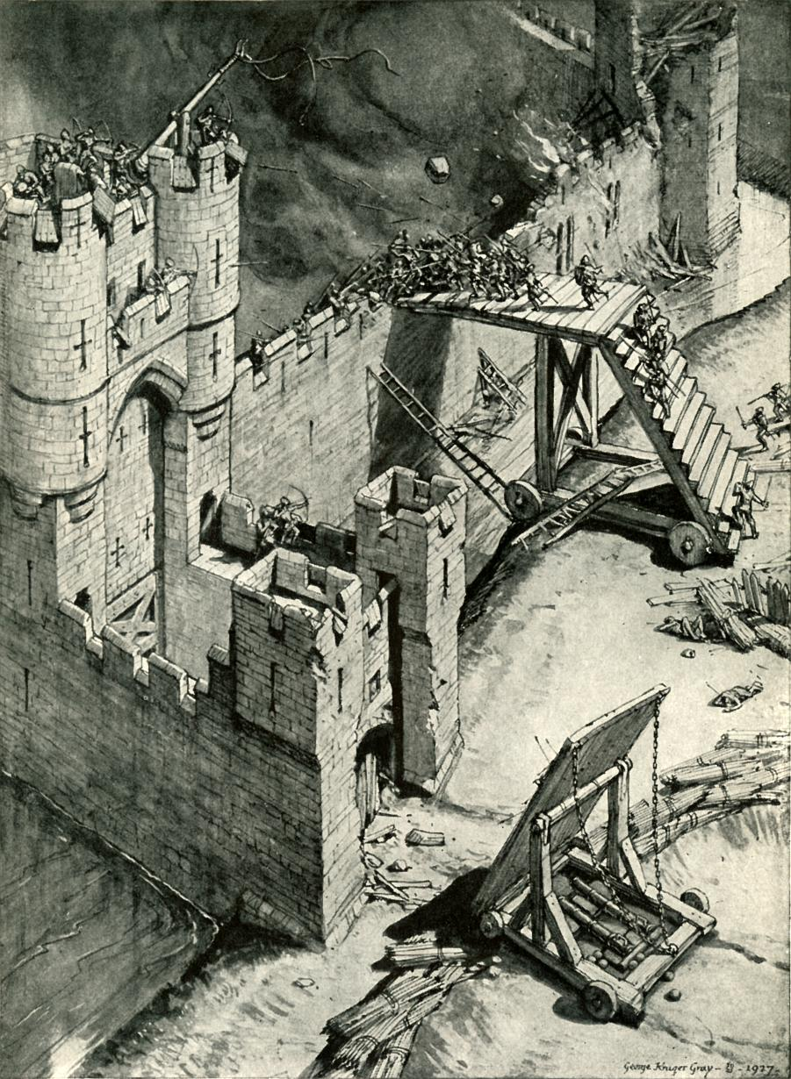
A. Players entering a hex which contains a Walled Structure: Keep, Fortress or Castle –

- The player attacking/claiming a HEX with a “walled” structure must enter the hex w/ the appropriate number of “Siege Tower” Units.

- Battles are then determined with normal Battle Resolution Rules.

- All Siege Units are LOST if the attacking player loses the battle.

- The defending player DOES NOT get to keep the Siege Units.

- If the attacking player WINS, then all “Siege Tower” units survive UNLESS the Battle Percentage Difference is less than 10% in which case ALL Siege towers while effective were destroyed!

- Siege Towers require at least a LVL I structure to be in the hex you wish to build them in. In addition, you may only build 1 siege tower for each LVL of your structure. (In other words, you may only build 1 siege tower in a hex with a LVL I tower but you may build, for example 4 siege towers in a hex with a LVL IV castle.)

VII. Heroes, DRAGONS, AND WIZARDS –

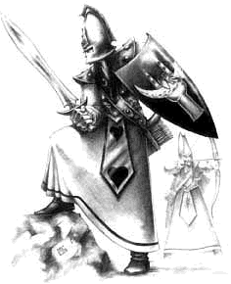
Heroes, Dragons & Wizards are legendary and in a game of legendary proportions, you will all get these unique characters. They may be utilized to add a variety of elements to the game. At first heroes will do nothing more than add modifiers to players existing Units but, as the game progresses, these elite units may venture upon quests and acquire new weapons, skills to help players adapt to new situations, terrain, etc to bring a new dimension to the game (possibly bring new training for newer Structures, Units and Evolutions?)

In addition, Heroes, Dragons & Wizards are also you’re “Big Leaguers” and as such, between players, they may be traded, borrowed, stolen, tortured, seduced, bribed, killed, and even sold to each other but, remember one thing, these units are “legendary” and as such their actions are very well known and publicized in the lands of DAVEN.

However you choose to use this feature, I hope you enjoy this very ambiguous and “creative” element of the game.

FOR HERO PROFILES see APPENDIX C

FOR DRAGON PROFILES see APPENDIX D

FOR WIZARD PROFILES see APPENDIX E

VIII. DIPLOMACY –

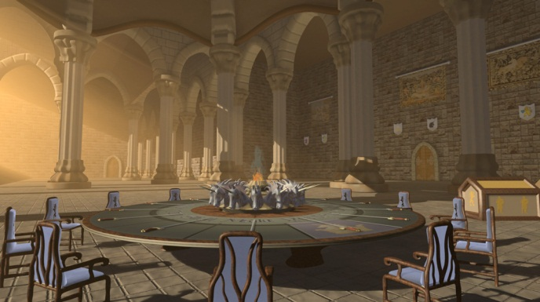
A. It’s pretty simple – Anything goes, but it goes through me. I understand that as the GM, it may be a hindrance for both you and me to “pass notes back and forth” between players but, what I do ask/require is that all final agreements, trades, anything that will affect the outcome of the game is sent through me – Please. Feel free to converse amongst yourselves but all I ask is that I get a CC on the emails* - unless of course you wish to complain about the GM, then keep me out of it!. (Thank you!)

*NOTE: There are variables that may need to be rolled, so keep in mind that you and another player may spend hours working out an agreement that in the end, I may not honor or I may have to roll a die variable to see if the situation should be altered (E.g. rolling a 1d100 fate roll for a messenger to see if he was intercepted, killed, bribed, etc.)

NOTE: As the GM (and as in most DM type games), there are set (classified) guidelines AND as well, possible additional variables that you as a player are NOT aware of for the sake of keeping the game creative and you, the players, on your toes. :o)

IX. LEADERS, ASSASSINATIONS, AND WINNING THE GAME

So what the heck is TSNS all about? … Well, winning of course. So how do you win – simple be the last one standing!

A. Leaders -

Each player will rule their empire as their “leader.”
Additional information has been removed due to no utilization.

B. Assassinations –

Units capable of assassinations have been removed from the game.

C. Winning the Game -

To win the game, simply be the last empire (or allied empires) on the board and own all the hexes. (Keep in mind that the map of Daven may be only a part of a larger map with perhaps more players? Or players previously removed from the game returning for revenge? Ideas are endless for this aspect!?

Well gang that’s it, additional rules revisions and changes are sure to come with time. Until then, you have this and good luck…

Appendix A

Table A. Unit/Structure Cost and Upkeep

Unit/Structure | BUILD Cost | Move | B.R. | Upkeep COST
Swordsman (S) | 5k | 2 | N/A | 5k/yr
Long Swordsman (LS) | 10k + (S) | 2 | I | 5k/yr
Archer (A) | 10k + (S) | 2 | I | 5k/yr
Cavalry (C) | 15k + (LS) | 2 | (II) | 5k/yr
Marksman (M) | 15k + (A) | 2 | (II) | 5k/yr
Heavy Cavalry (HC) | 20k + (C) | 2 | (III) | 5k/yr
Ballista (B) | 20k + (B) | 2 | (III) | 5k/yr
Knights (K) | 25k + (HC) | 2 | (IV) | 5k/yr
Catapult (T) | 25k + (B) | 2 | (IV) | 5k/yr
Tower/Toll House - I | 50k | N/A | N/A | 25k/yr
Keep (W) - (II) | 100k + Tower | N/A | N/A | 50k/yr
Fortress (W) - (III) | 200k + Keep | N/A | N/A | 75k/yr
Castle (W) - (IV) | 400k + Fortress | N/A | N/A | 100k/yr
Siege Tower (#) | 50k | 2 | I | 0k/yr
HEROES | Table H. | Table H. | N/A | Table H.
¹ See Notes Section IV. Subpart C & D for movement modifiers (if applicable)

(W) – Indicates the structure is considered a “Walled” Structure.

* - You may only have one Knight Unit progress beyond the status of Knight at a time. NOTE: All subsequent Units carry the modifiers of the previous evolution. (E.g. A Ranger Unit will have the modifiers for a RANGER Unit PLUS the modifiers for a Paladin Unit. Modifiers for Knight Units and below Do Not carry forward.

Table B. Battle Initiative for more than three players entering a hex.
Battles with four players –

(Highest Roll) |  | (2nd Highest Roll)
(Lowest Roll)* | Winner (w/ BVR) vs. Winner (w/ BVR) | (2nd Lowest Roll)*

Battles with five players –

Highest Roll = A
2nd Highest Roll = B
2nd Lowest Roll = C
3rd Lowest Roll = D*
Lowest Roll = E

Winner of A vs. E = WAE
Winner of B vs. C = WBC
Winner of WBC vs. D = WBCD

A |  |  |  | B
E | WAE |  | WBC | C
 |  | WAE vs. WBCD | D*

Battles with six players –

Highest Roll = A
2nd Highest Roll = B
3rd Highest Roll = C*
3rd Lowest Roll = D*
2nd Lowest Roll = E
Lowest Roll = F

A |  |  |  |  |  | B
F | WAF |  |  |  | WBE | E
 | D* | WAFD |  | WBEC | C*
 |  |  | WAFD vs. WBEC

* Position assumed by player that OWNS the hex (for all conditions.)

Table(s) F. Fate Rolls and Results
Fate rolls are the “destiny” (luck if you will) of your empire and the lands of DAVEN. These rolls will be rolled for each and every turn individually for each player and the results annotated in your turn summary. NOTE: For most situations, the GM will have a table that will dictate the outcome of Fate rolls. The tables below indicate the majority types of Fate rolls and their outcome –
At the beginning of each turn, each player will be rolled a 1d100 Fate roll for their empire’s land. A roll result of 96-100 will result in a natural event. The event will be determined as follows –
An additional roll of 1d20 will be rolled to see if it is either a penalty or reward to your empire –
- A roll result of odds will result in a disaster penalty
- A roll result of evens will result in a reward payout

An additional roll of 1d10 will be assessed and the following will be attached to your turn summary on the next turn (indicates percent of KWAN you lose/gain for that year (turn) –

Table F.a. Land Fate Rolls

1d10 Result | Disaster | Penalty(Loss) |  | Reward | Payout(Gain)
1-3 | Mild Fires | 5% |  | Surplus Food | 5%
4-5 | Mild Uprising | 10% |  | Good Crops | 10%
6 | Mild Disease | 15% |  | People Praise You | 15%
7 | Major Fires | 20% |  | Vigorous People | 20%
8 | Major Uprising | 25% |  | Good Health | 25%
9 | Poor Harvest | 30% |  | Fertile Land | 30%
10 | Plague | 35% |  | Great Harvest | 35%

NOTE: The TABLES on following pages - F.b, F.c, F.d, have been MODIFIED/RENAMED in this ADVANCED RULES Set.

Table F.b. Hero/Dragon/Wizard Fate Roll (Losing Battle)

1d100 Result | FATE of Hero
1-10 | Survives & Escapes – 5 Hexes (Losing Player’s Choice)
11-20 | Survives & Escapes – 4 Hexes (Losing Player’s Choice)
21-30 | Survives & Escapes – 3 Hexes (Losing Player’s Choice)
31-40 | Survives & Escapes – 2 Hexes (Losing Player’s Choice)
41-50 | Survives & Escapes – 1 Hex (Losing Player’s Choice)
51-60 | Survives & Hides (Standard FATE Roll for Discovery)
61-70 | Surrenders (Opposing Player Controls*)
71-80 | Captured (Opposing Player Controls*)
81-90 | Wounded & Captured* (Roll -1d10 Dexterity Modifier - permanent)
91-95 | Wounded & Captured* (Roll -2d10 Dexterity Modifier - permanent)
96-100 | Killed in Action

NOTES:
* A Hero/Dragon/Wizard (H/D/W) that an “Opposing Player Controls” or is “Captured” may be moved up to their maximum movement as assigned by the Opposing Player however, a H/D/W that an “Opposing Player Controls” or is “Captured” May Not be used for battle by the Opposing Player.

If however, the Opposing Player encounters a subsequent battle with the Player who originally “owns” the Captured H/D/W and Loses that battle, the H/D/W will be freed but WILL NOT have fought in the battle.

If the Opposing Player encounters a subsequent battle with a Player who DOES NOT originally “own” the Captured H/D/W and Loses, the H/D/W will be subjected to another Table F.b Hero FATE roll.

H/D/W’s that are captured and brought back to the Opposing player’s Castle are considered imprisoned. Imprisoned H/D/W may only be freed at the will of the Opposing player. The Player who owns the H/D/W may have to pay the Opposing player a fee (kWan, Units, etc.) for his release. Keep in mind, captured H/D/W’s are constantly attempting to escape EVERY turn via a fate roll whether you ask them to or not!
(NOTE: You may interrogate a Hero!? (Hint Hint)

Table F.c./F.d Special Unit Abilities & Fate Rolls

Table F.c. - Fate Roll for Miscellaneous Endeavors

1d100 Result | Fate Result for Miscellaneous Endeavor
1-25 | Failure
26-50 | Failure (and detected)*
51-75 | Failure (and identified)*
76-90 | Failure (and captured)*
91-100 | Success

Table F.d. - Fate Roll for Miscellaneous Endeavors (High Failure)

1d100 Result | Fate Result for Miscellaneous Endeavor
1-25 | Failure
26-50 | Failure (and detected)*
51-75 | Failure (and identified)*
76-95 | Failure (and captured)*
96-100 | Success

* If Applicable for the Endeavor (E.g. A player attempting to build ships pays a fee and using Table F.d. rolls a Fate roll of 57. That player will not be successful but the other player will receive “news” of the failed endeavor.)

Appendix B (GM/Player Guidelines & Assumptions)

The purpose of The Sun Nevers Sets (TSNS) is to set players into a world where they may “personally” alter their empire’s fate. Although there are “rules” in TSNS, the GM may be flexible in his monitoring/supervision of the game and how much player’s may “personally” affect the game. Suggestions are as follows (in no particular order)

For the Game Master (GM)-

- Practically “anything” a Player wishes to attempt/research MUST be considered by the GM and the decision whether the action to be attempted is realistic and within the scope of the game. This decision is ALWAYS at the DISCRETION of the GM (DotGM.) - (E.g. a Player asks the GM if he can build a rocket ship – Negative. Another player asks if he can research bridge building – Certainly … for a ridiculous fee of course!) The GM decision on these matters is final and binding to ALL players.

  - This attempt should cost (again at the DISCRETION of the GM (DotGM)) some pre-determined amount of Kwan and annotated by the GM so as to charge a similar amount to subsequent player’s that attempt “similar” goals.

  - The ability researched by one player is automatically available (if they also request/ask to attempt it or hear about another player’s failed attempt) to ANY of the other player’s and MAY even be SOLD by the player who accomplished it for whatever fee he chooses.

NOTE: GM should be sure to annotate what has been approved/denied so as to apply the same allowances/restrictions to ALL players.

- Fate Rolls should be conducted for anything (see I. above) a player wishes to attempt outside the scope/rules of the game. There should always be a Minimum 10% chance (unless otherwise noted in the rules or at the DotGM) of failure for the task. (E.g. a Player requests that they wish to learn how to build/destroy bridges; a skill not inherent within the current game rules/settings. The GM should request a fee to “research” this skill and then roll a Fate Roll (use Table F.d.) to see if the player is successful in learning this skill.)

  - Skills and attempts of higher degrees of difficulty, again at the DotGM, should require higher fees and a higher failure percentage. (E.g. While the player in the example in II. above had a 10% failure for researching ship building; Another player trying to research a “flying” Unit may have higher fees and a failure percentage of say 95%? (use Table F.e.)

- There should be plenty of (pre-set/hex) “Easter Eggs” for player’s to roll a Fate roll against when they land upon that hex. (E.g. Player 1 stops a Unit upon a hex adjacent to water that contains an “Easter Egg” (with a percentage of discovery pre-set at 5% (use Table F.e.) of an old boat - which would yield the ability to develop and build new boats. Player 1 would need to Fate roll a 1d100 (independent from their standard 1d100 Land Fate roll at the beginning of each turn) against that hex each and every turn that they own it until they either no longer own it, or discover the “Easter Egg” (The result of 96 or higher in this example would yield the discovery.)

For the Player -

- Player’s may engage one another outside the game for purposes of (just to name a few) – conducting deals; such as trading/selling new technologies, heroes, information, setting up alliances, etc. however, keep in mind that ALL final communications should go through the GM for a Ruling. (E.g. Player 1 and Player 2 agree to trade heroes. If their lands are adjacent to each other then so long as they notify the GM (both must notify the GM of this transaction) the trade is conducted however, If they do not border one another or any other “Allied” player, they must consider that at the DotGM - a Fate roll will be considered to determine if (even though they notified the GM) the trade was successful, or not, in relaying the information as he had to travel through “unfriendly” territory. NOTE: Keep in mind that a Paladin, Ranger or Assassin Unit may intercept such messengers.

- Mistakes in Orders – Player’s (as well as the GM) must understand the “human” element of the game may, at times cause mistakes and thus errors. So therefore, Mistakes by the player will be dealt with as if they were a “true human element” and thus, no action will be taken by the GM as to “hypothesize” what the player intended and thus, no action will be taken. (E.g. A Player orders movement for his Swordsmen and Cavalry Units to move adjacently to a hex. The player however miscalculated and if the GM carries out the order, the Player’s Units will be split. Rather than split the Units, the GM will take no action and the Units will not be moved. (This would be assumed as if orders never made it to the troops.) So be sure to be careful.

Mistakes on the part of the GM will be fixed accordingly and in a timely manner so as to not (at least in intention) affect the outcome of the turn/game.

- Player/Realm Continuity – As was the case in the first “beta” test of TSNS I. Two players opted out of the game prior to the completion of the game. Their realms remained “active” throughout the remainder of the game and were subsequently overthrown.

For the continuity of the game and the “realistic” aspect of the realm, the GM reserves the right to allow a NEW player to take over an existing kingdom in which a player has opted out. This option may take place anytime during the game.

Anyway, I think you get the gist of this. Basically, the role of the GM is to keep the player’s thinking, without being prejudicial to any one player and allowing them some impartial “freedom” to let the game take some shape and personality of its own.

Appendix C Hero Profiles

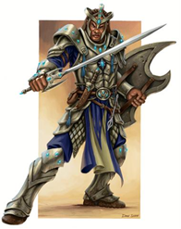 | Lord Alphan – aka “The BattleMaker”  Strength - 93 (9d10+31)  Dexterity - 92 (6 hex/turn)  Intelligence - 96  Although a little impulsive, Lord Alphan is legendary in his ability to lead men and is known to bring an advantage in pivotal battles.  Modifiers -  All Knights Units gain +1 to All Attack rolls.
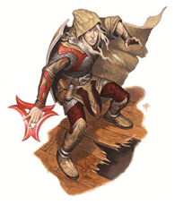 | Betaff – aka “Darkwalker”  Strength - 92 (9d10+31)  Dexterity - 94 (6 hex/turn)  Intelligence - 91  Highly skilled in the ways of Paladins and Thieves, Betaff is a most cunning, clever and dangerous asset, bringing advanced skill to already formidable Units.  Modifiers -  All Archer/Marksmen Units gain +1 to All Attack Rolls

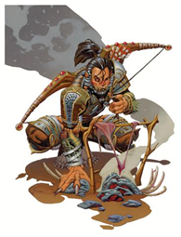 | Gammane – aka “The Sharpshooter”  Strength - 90 (9d10+30)  Dexterity - 96 (6 hex/turn)  Intelligence - 95  Trained as a Paladin and surpassing most of his fellow colleagues, Gammane has quickly become a legendary tracker and threat to any opposing players.  Modifiers –  All Archer/Marksmen Units gain +1 to All Attack Rolls
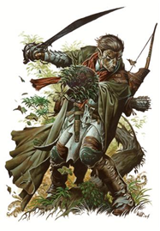 | Deltar – aka “Lone Wolf”  Strength - 91 (9d10+30)  Dexterity - 97 (6 hex/turn)  Intelligence - 93  Deltar, trained originally as a Ranger, went “Dark” years ago. Many have heard rumors about seeing him in towns all over Daven but most say its people are just “crying Wolf.”  Modifiers -  All Archer/Marksmen Units gain +1 to All Attack Rolls

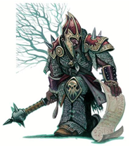 | Epsone – aka “The Sword Tamer”  Strength - 97 (10d10+32)  Dexterity - 92 (6 hex/turn)  Intelligence - 86  Epsone, a soldier by nature has become one of the most revered warriors in all of Daven. He inspires Units to fight and fight for him they will.  Modifiers –  All Infantry Units gain +1 to All Attack Rolls
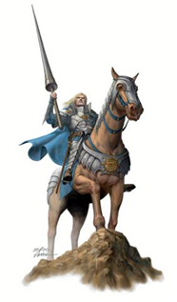 | Lord Zetar – aka “The Noble Horsemen”  Strength - 98 (10d10+33)  Dexterity - 94 (6 hex/turn)  Intelligence - 88  Lord Zetar, a self-proclaimed Lord, has the reputation of being one of (save only to Lord Omegan) the most feared and unstable Warriors in Daven. Men fight hard for him; not out of loyalty but for fear of his punishment if they lose.  Modifiers – All Cavalry/Heavy Cavalry Units Gain +1 to All Attack Rolls

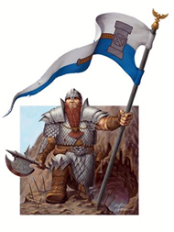 | Etam – aka “The Flag bearer”  Strength - 96 (10d10+32)  Dexterity - 92 (6 hex/turn)  Intelligence - 92  Etam, an accomplished and seasoned warrior is well known for his boisterous spirit and ill regard for the enemy. He has been known to march into battle with his flag rather than his sword – his men love him.  Modifiers –  All Infantry Units gain +1 to All Attack Rolls
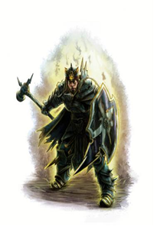 | Thetam – aka” The Dark Knight”  Strength - 96 (10d10+32)  Dexterity - 93 (6 hex/turn)  Intelligence - 87  Thetam, brother to Etam has been known to be the “Black” Sheep of the family. Envious of his brother’s achievements, Thetam has recently begun to make a name for himself. Men are beginning to see his strength.  Modifiers –  All Swordsmen/Long Swordsmen gain +1 to All Attack Rolls

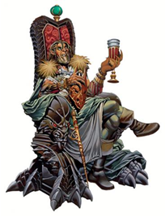 | Iotane – aka “Jester”  Strength - 93 (9d10+31)  Dexterity - 97 (6 hex/turn)  Intelligence - 99  Iotane, an Assassin by trade has become a bit aloof and unstable. Now a consultant and Master strategist, he is often found drunk in his quarters.  Modifers -  All Infantry Units gain + 1 to their Attack Rolls
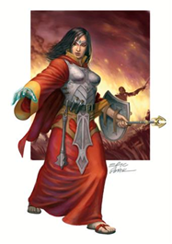 | Lady Kappan – aka “The Soft Touch”  Strength - 90 (9d10+30)  Dexterity - 95 (6 hex/turn)  Intelligence - 93  Although once a common peasant, Lady Kappan’s innate ability for medicine has made her the leading healer in Daven. If you’re sick, she’s your girl.  Modifiers –  After a battle 1d20 (if applicable) of the highest ranking* Units eliminated will be returned to the winning army.  *Ranking will be (Highest to lowest) – K, HC, C, M, A, LS, S (B & T are not returned)

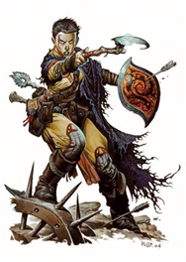 | Lamdaw – aka “Blademaster”  Strength - 95 (9d10+32)  Dexterity - 97 (6 hex/turn)  Intelligence - 96  Lamdaw, a young but master swordsman is renowned for his ability to wield a deadly weapon. His uncanny ability to teach these skills at a rapid pace makes him an even deadlier adversary.  Modifiers -  All Swordsmen gain 1 Additional Attack Roll
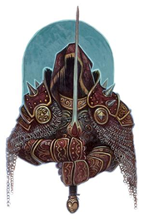 | Noble Omegan – aka “The DeathDealer,” “The Reaper”  Strength - 99 (10d10+33)  Dexterity - 95 (6 hex/turn)  Intelligence - 98  Lord Omegan, known simply as “The DeathDealer” and/or “The Reaper,” is by far the most feared warrior in all of Daven. He is unsurpassed in leadership, swordplay and strength; He is the total package and his men will fight to the death for him.  Modifiers –  All Infantry Units gain +2 to All Attack Rolls
Special Unit Ability of Assassin 1 and below applied to ALL Heroes in addition to their normal modifiers

Appendix D Dragon Profiles

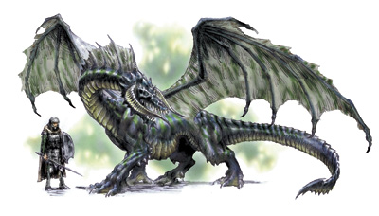
BLACK Dragon –

Black dragons are vile, evil tempered, and obsessed with death. They live in fetid, swampy habitats. They find comfort in the sickening-sweet aroma of drowned, rotting carcasses. The black dragon's domain is the swamp and the jungle. They are abusive, quick to anger, and malevolent. Their hearts are as black as their slimy scales

Attack - 5d10
Move – 6 hex/turn
Modifier - All Infantry Units gain +1 to All Attack Rolls
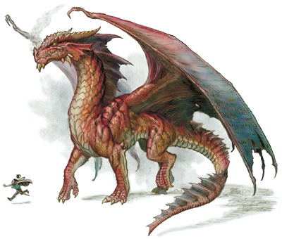

RED Dragon -
Red dragons are greedy and covetous, and obsessed with increasing their treasure hoards. They live in warm habitats, such as volcanoes or tropical islands. The red dragon's domain is the mountain and the island. They are vain, cunning, and terrible.
Attack - 5d10
Move – 6 hex/turn
Modifier - All Infantry Units gain +1 to All Attack Rolls
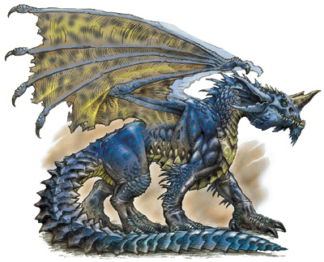

BLUE Dragon -
Blue dragons are pensive, lawful, and vain. They live in hot, dry areas, such as sandy deserts or arid steppes.
Attack - 5d10
Move – 6 hex/turn
Modifier - All Archer/Marksmen Units gain +1 to All Attack Rolls

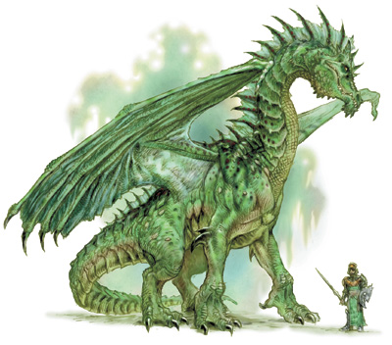
GREEN Dragon -
The green dragon is a belligerent creature and master of intrigue, politics, and backbiting. He is cruel. He prefers forests—the older and bigger the trees, the better. Instead of being overtly aggressive, he prefers to concoct elaborat schemes to gain power or wealth with as little effort as possible. He may make his lair behind a waterfall or near a lake, pond, or stream that provides a submerged entrance. The closer one gets to his lair, the darker the woods become. Evil hangs in the air, mingling with the forest scents to produce foul odors.
Attack - 5d10
Move – 6 hex/turn
Modifier - All Infantry Units gain + 1 to their Attack Rolls

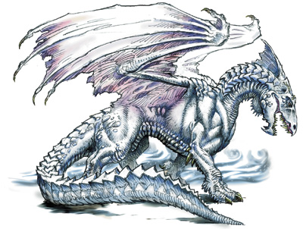
WHITE Dragon -
White dragons are small and intelligent. They live in frigid, icy climates — usually arctic areas, but sometimes very high mountains. They travel alone, and have very good memories. They prefer the solitude of snowy plains and caves, far away from the warming rays of the sun.
Attack - 5d10
Move – 6 hex/turn
Modifier - All Archer/Marksmen Units gain +1 to All Attack Rolls

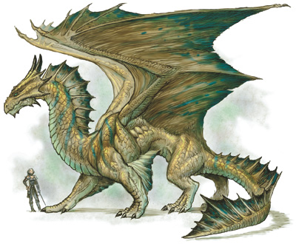
BRONZE Dragon -

Having a strong sense of justice, bronze dragons do not tolerate cruelty or anarchy in any form. They are also inquisitive and find humanoids fascinating. They live near deep water, especially in tropical costal areas and islands. They wage a constant struggle against evil sea creatures, and often live in caves or near underground streams or lakes.

Attack - 5d10
Move – 6 hex/turn
Modifier - All Archer/Marksmen Units gain +1 to All Attack Rolls

GOLD (Yellow) Dragon -

Gold dragons are champions against evil and foul play. They often embark on self-appointed quests to promote good. They make their lairs in secluded areas, such as deep gorges or high plateaus.

Attack - 5d10
Move – 6 hex/turn
Modifier - All Knights Units gain +1 to All Attack rolls.

SILVER (White) Dragon -

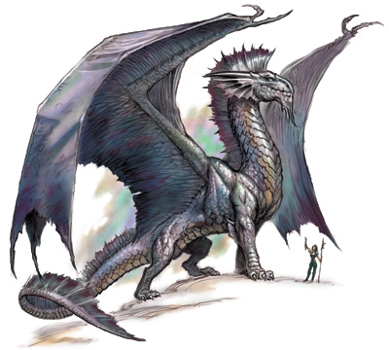
These dragons enjoy helping the meek and the lowly. They often concern themselves with protecting the innocent and healing their injuries. They love high mountains and vast, open skies with billowing clouds. They enjoy flying and sometimes soar for hours just for the pleasure of it.

Attack - 5d10
Move – 6 hex/turn
Modifier - All Cavalry/Heavy Cavalry Units Gain +1 to All Attack Rolls

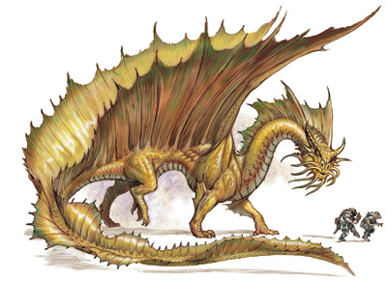

Appendix E Wizard’s Council
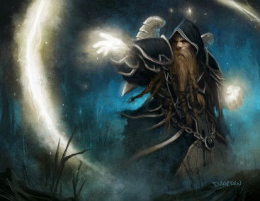 | NUMA “The Black Ghost” (Adept)  NUMA “The Black Ghost” is an Adept; a wizard that is most concerned with outward manifestation of magical energy. He is cunning and feared among many of his peers for his awesome offensive ability  Black Mages tend to practice offensive magic  Attack – 6d4/5d6/4d8/3d10/2d12/1d20 +30  Move – 6 hex/turn
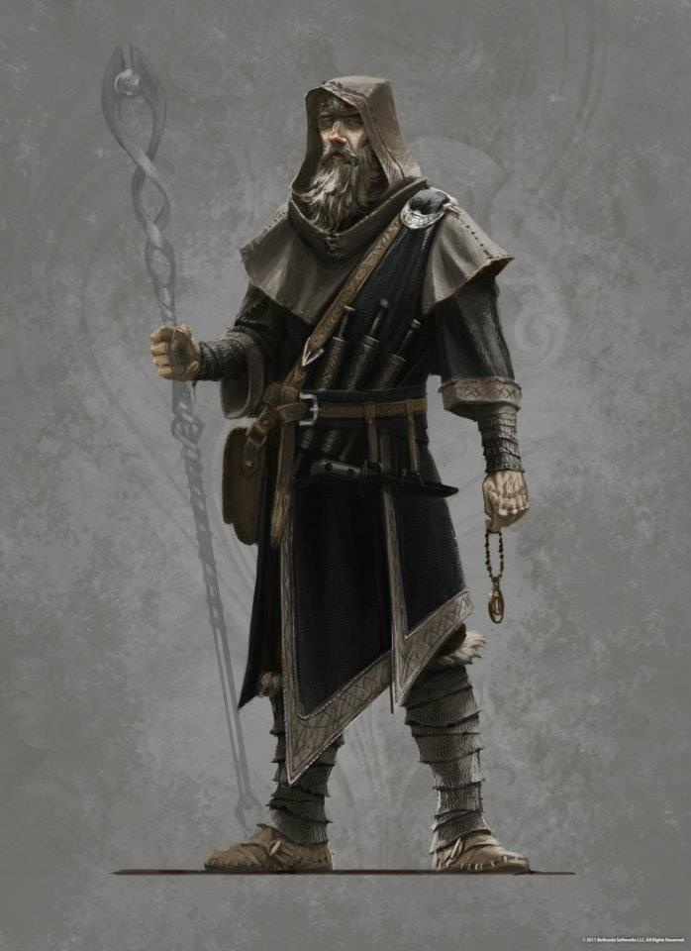 | ENDRE “The Savior” (Cleric)  Endre “The Savior” was once a “High Cleric” of an organized group of a religious organization that used magic to cure illness. Endre was cast out for his “unorthodox” use of healing magic to inflict pain upon enemies thus turning the healing into harming. Called upon by Danick “The Wise” in his quest for Tronde “The Corrupt”, Endre was able to use his magic again for healing and help prevent more casualties in Battle of Caverna Tronde.  White Mages tend to practice healing magic  Attack - 6d4/5d6/4d8/3d10/2d12/1d20 +30  Move – 6 hex/turn

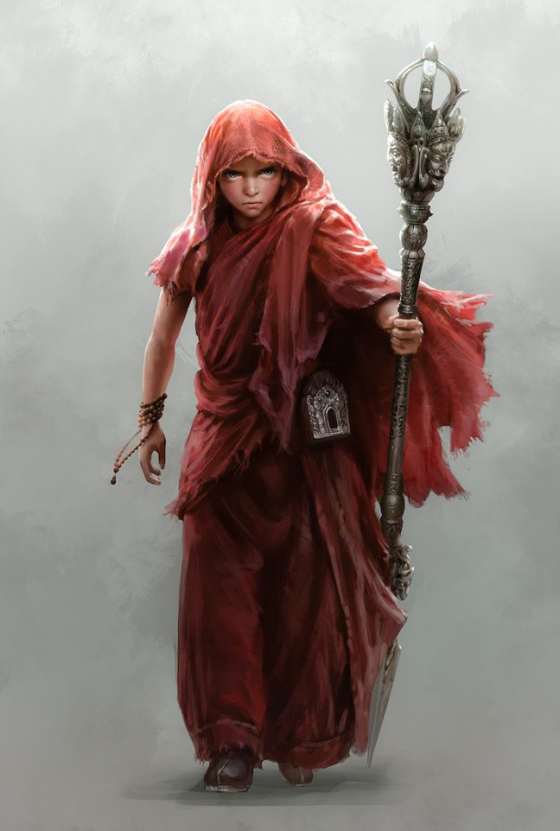 | TIANA “The Siren” (Enchantress)  Tiana “The Siren” is an enchantress; a magic user who specializes in (or practices only) in magic of enchanting, seducing and tempting. Cast out of the Council of Wizards (now defunct) for her; “mismanagement of magic for practical purposes” she simply walked out of the council hall uttering the words; “Didn’t want to be in this stupid boys club anyway!” Known throughout as the wizard with “looks that kill”, she is the envy of many a suffering woman and the dread of ruthless men.  Pink (Red) Mages are a Jack-Of-All trades but do lean towards white (healing) magic  Attack - 6d4/5d6/4d8/3d10/2d12/1d20 +30  Move – 6 hex/turn
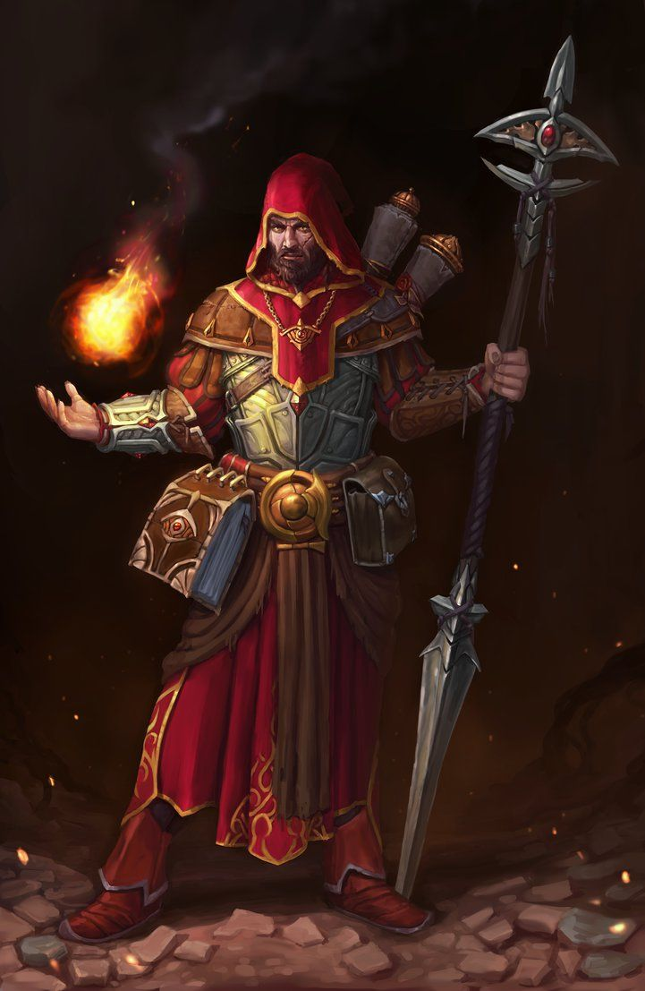 | NORDIN “The Red” (Adept)  Nordin “The Red” (also an Adept) is a wizard that tends to fall into the textbook wizard category (the "pointed hat and wand" variety.) Although it is not the predominant wizard type, Nordin is, by far, the most stereotypical wizard in the land. That said however, many victims have found themselves on the receiving end of a brutal, torturous onslaught delivered by one of the deadliest wizards alive. His well-documented mastery of multiple classes of magic have earned him the additional nickname the “Chamaeleōn Magicum” (Magical Chameleon) Nordin has been and successfully survived three separate attacks by Tronde “The Corrupt” for his Spell Book.  Red Mages are a Jack-Of-All trades  Attack - 6d4/5d6/4d8/3d10/2d12/1d20 +30  Move – 6 hex/turn
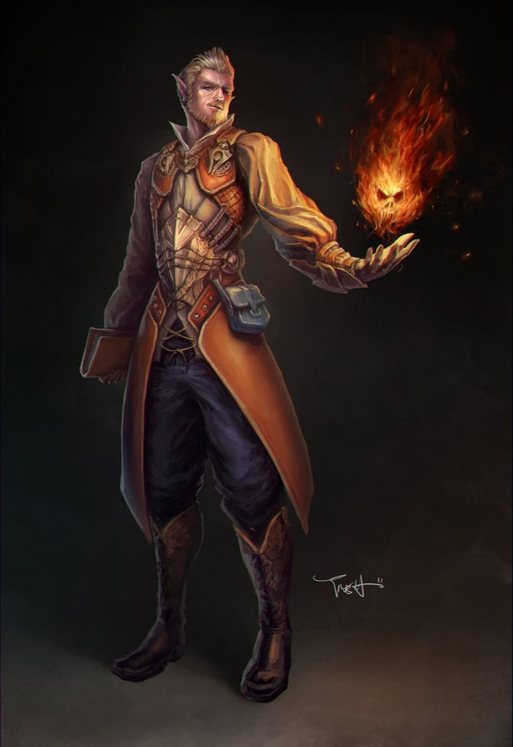 | 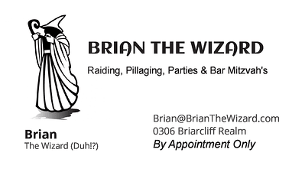  Brian “The Wizard” is a light-hearted, jovial, but often deadly yellow mage that practices “Light Magic” by utilizing hot or bright elements. While mild mannered, great with the kids, and often smiling, this wizard is not to be underestimated. He once defeated 3 opponents by shouting “FIREBALL!, FIREBALL!, FIREBALL!” and laughed hysterically while they burned to death!?...  Attack - 6d4/5d6/4d8/3d10/2d12/1d20 +30  Move – 6 hex/turn
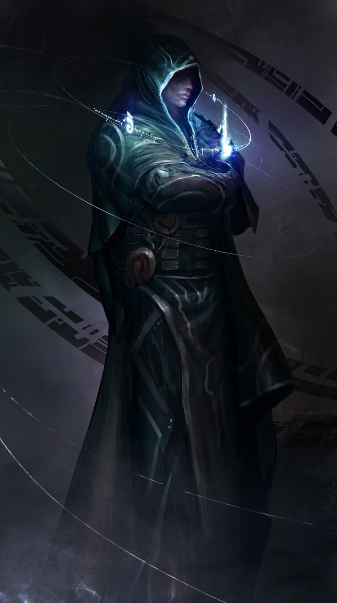 | DANICK “The Wise” (Archmage Conjurer)  Danick “The Wise” is an Archmage, which is a mage or magus of high status and power. He was formerly the “Wizard Prime” of the Council of Wizards (now defunct); Danick was chosen for the position for his even-tempered, even-balanced approach to magic and governing the Council fairly. It should be noted that Danick was also chosen as he has been deemed by many master wizards, and apprentices alike, to be the most powerful wizard that ever lived. Disenchanted with the growing contempt for the Council Laws, Danick decided to disband the Council simply saying; “It is far better to be alone, than to be in bad company.” Danick was last seen during the Battle of Caverna Trond.  Green Mages practice Green Magic, which enhances allies' abilities and weakens enemies  Attack - 6d4/5d6/4d8/3d10/2d12/1d20 +30  Move – 6 hex/turn

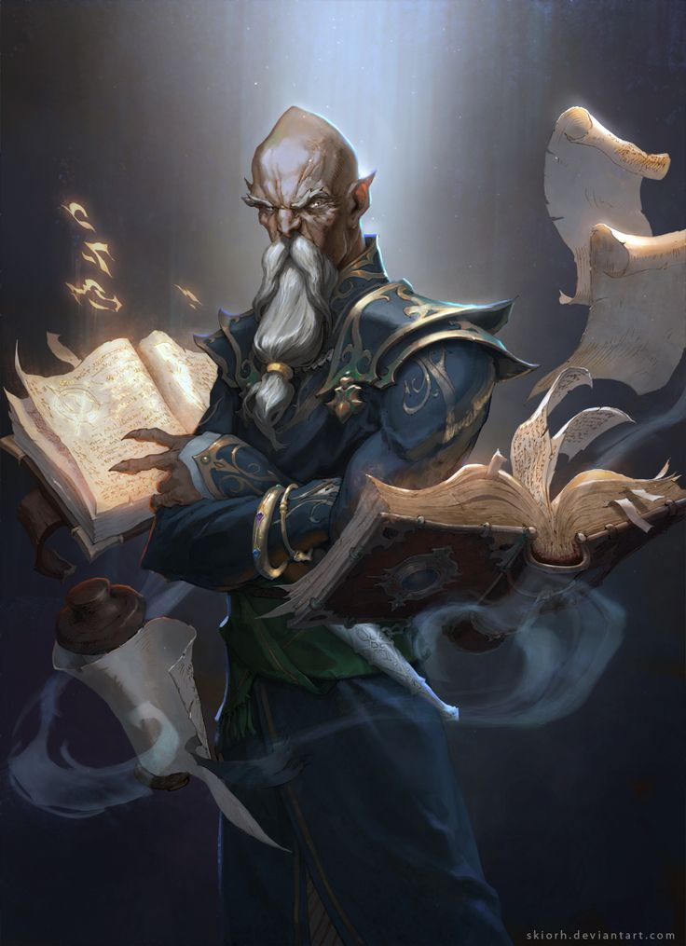 | TRONDE “The Corrupt” (Sorcerer)  Tronde “The Corrupt” is an evil magic user and as a young apprentice, infamous for killing his master and stealing his spell book. Over the next several years, Tronde murdered many more wizards and adopted their magic as his own. His actions went unchecked for many decades until Danick, along with several members of the Council of Wizards (now defunct), sought Tronde in Caverna Trond deep in the realm of Trondeheim. After a brutal encounter, which killed many Council wizards and injured others (including Danick), Tronde was finally defeated and stripped of his stolen spell books. Perpetually banished from the Council of Wizards, he has been seen wandering the lands with a single Blue book entitle Magicae Libellus. He is still considered a most dangerous wizard.  Blue Mages copy enemy abilities  Attack - 6d4/5d6/4d8/3d10/2d12/1d20 +30  Move – 6 hex/turn
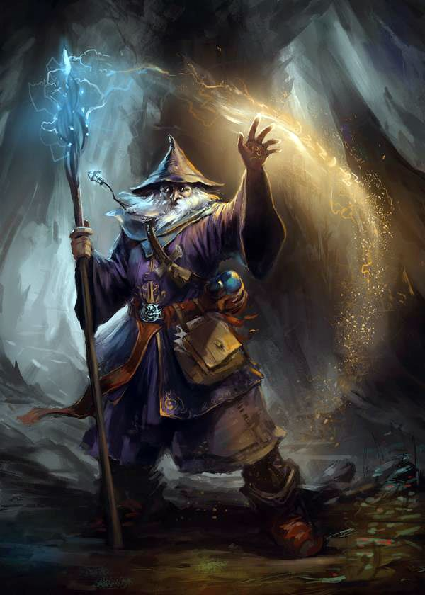 | NYRO “The Conduit” (Elementalist)  Nyro “The Conduit” is an elemental magic user who specializes in (or practices only) magic connected to the four elements: Earth, Water, Air and Fire. Nicknamed “The Conduit” by his enemies, Nyro is said to have the master command of the four elements and ability to direct them at will. Relying heavily on the element of Earth and dark magic in the Caverna Trond, Nyro was pivotal in the eventual defeat of Tronde “The Corrupt” and recovering the stolen magical tomes of slaughtered wizards. Since the Fall of the Council of Wizards, Nyro has gone into seclusion with rumors that he has ventured far south.  Purple Mages tend to gravitate towards Blue & Red (sometimes Black Mage) abilities.  Attack - 6d4/5d6/4d8/3d10/2d12/1d20 +30  Move – 6 hex/turn

Wizard Council Rules –

OK – So, just to make sure you don’t go running amuck and wreaking havoc among our neighbors and such, I just want to make sure you understand the rules regarding wizards –

Basically they have a finite amount of energy and thus they cannot affect the same damage from battle to battle so. If you look at the wizards attack value you’ll see that they are basically a multiplier of 6 (6d4/5d6/4d8/3d10/2d12/1d20.) Meaning, there are six levels to their ability to fight. (This represents low level, low energy, low risk, low yield spells cast through the higher level, extreme energy, high risk but potentially devastating spells)

So in a battle a wizard will roll a 1d6 to determine what level he/she is capable of rolling too in that turn (Spells progression is always low energy to high energy – you don’t pick)…
e.g. Danick rolls a four – thus he can only roll a 6d4/5d6/4d8/3d10 + 30) for his damage total for that turn. (Which I just rolled, would’ve been 12/12/15/17 +30 for a AR of 86!)

Each subsequent turn will yield another 1d6 spell progression roll for battle.

A wizard that rolls a six will get ALL spell attack rolls AND a wizard that is located within a (WALLED) structure will automatically get ALL of their ATTACK ROLLS because, you know, they have time to conjure up loads of spells and not worry about fighting in melee combat! Anyway, you get my drift… they aren’t immortal and/or invincible but, they can be devastating with the right combination of rolls!?...

Appendix F . LEGACY Weapon Profiles
Coming Soon!
The Sun Never Sets
Copyright 2006-2016. FUBAR GAMES. Outside The Cube.

WWW.FUBARgames.com

Appendix Z (Reference Materials)

1. Medieval catapults

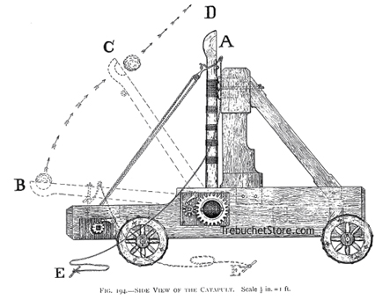
A catapult is a device used to throw or hurl a projectile a great distance without the aid of explosive devices—particularly various types of ancient and medieval siege engines.^{[1]} Although the catapult has been used since ancient times, it has proven to be one of the most effective mechanisms during warfare. The word 'catapult' comes from the Latin 'catapulta', which in turn comes from the Greek καταπέλτης (katapeltēs), itself from (kata), "downwards"^{[2]} + πάλλω (pallō), "to toss, to hurl".^{[3][4]} Catapults were invented by the ancient Greeks
Castles and fortified walled cities were common during this period - and catapults were used as a key siege weapon against them. As well as attempting to breach the walls, incendiary missiles could be thrown inside—or early biological warfare attempted with diseased carcasses or putrid garbage catapulted over the walls.
Defensive techniques in the Middle Ages progressed to a point that rendered catapults ineffective for the most part. The Viking siege of Paris (885–6 A.D.) “saw the employment by both sides of virtually every instrument of siege craft known to the classical world, including a variety of catapults,” to little effect, resulting in failure.^{[7]}
The most widely used catapults throughout the Middle Ages were as follows:^{[25]}
Ballista
Ballistas were similar to giant crossbows and were designed to work through torsion. The ammunition used were basically giant arrows or darts made from wood with an iron tip. These arrows were then shot “along a flat trajectory” at a target. Ballistas are notable for their high degree of accuracy, but also their lack of firepower compared to that of a Mangonel or Trebuchet. Because of their immobility, most Ballistas were constructed on site following a siege assessment by the commanding military officer.^{[25]}
Springald
The springald's design is similar to that of the Ballista's, in that it was effectively a crossbow propelled by tension. The Springald's frame was more compact, allowing for use inside tighter confines, such as the inside of a castle or tower. This compromised the firepower though, making it an anti-personnel weapon at best.^{[25]}
Mangonel
These machines were designed to throw heavy projectiles from a “bowl-shaped bucket at the end of its arm”. Mangonels were mostly used for “firing various missiles at fortresses, castles, and cities,” with a range of up to 1300 feet. These missiles included anything from stones to excrement to rotting carcasses. Mangonels were relatively simple to construct, and eventually wheels were added to increase mobility.^{[25]}
Onager
Mangonels are also sometimes referred to as Onagers. Onager catapults initially launched projectiles from a sling, which was later changed to a “bowl-shaped bucket”. The word 'Onager' is derived from the Greek word 'onagros' for wild ass, referring to the “kicking motion and force”^{[25]} that were recreated in the Mangonel's design. In terms of historical records, there's not much to go on. The most detailed account of Mangonel use is from “Eric Marsden's translation of a text written by Ammianus Marcellius in the 4th Century AD” describing its construction and combat usage.^{[26]}
Trebuchet
Trebuchets were probably the most powerful catapult employed in the Middle Ages. The most commonly used ammunition were stones, but “darts and sharp wooden poles” could be substituted if necessary. The most effective kind of ammunition though involved fire, such as “firebrands, and deadly Greek Fire”. Trebuchets came in two different designs: Traction, which were powered by people, or Counterpoise, where the people were replaced with “a weight on the short end”.^{[25]} The most famous historical account of trebuchet use dates back to the siege of Stirling Castle in 1304, when the army of Edward I constructed a giant trebuchet known as “Warwolf”, which then proceeded to “level a section of [castle] wall, successfully concluding the siege.”^{[26]}
Couillard
A simplified trebuchet, where the trebuchet's single counterweight is split, swinging on either side of a central support post.
Leonardo da Vinci's catapult
Leonardo da Vinci sought to improve the efficiency and range of earlier designs. His design incorporated used a large wooden leaf spring as an accumulator to power the catapult.^{[citation needed]} Both ends of the bow are connected by a rope, similar to the design of a bow and arrow. The leaf spring was not used to pull the catapult armature directly, rather the rope was wound around a drum. The catapult armature was attached to this drum which would be turned until enough potential energy was stored in the deformation of the spring. The drum would then be disengaged from the winding mechanism, and the catapult arm would snap around.^{[citation needed]} Though no records exist of this design being built during Leonardo's lifetime, contemporary enthusiasts have reconstructed it.

2. Ballista

The ballista (Latin, from Greek ballistēs, from ballein "to throw", plural ballistae) is a powerful weapon resembling a giant crossbow, to eject heavy darts singly or in groups. It is also sometimes referred to as a bolt thrower.
First ballistae were deployed in the ancient Greece, and were mainly large crossbows fastened on a mount. The first known appearance was in Syracuse, in Sicily, around 400 BC. Roman ballistae differenced for the use of torsion power, derived from two thick skeins of twisted cords acting on two separate arms. They fired usually large stones rather than bolts.
Ballistae in the Middle Ages launched bolts, and were thought to have inspired the European crossbow, though 5th century Chinese crossbows may have also been a factor in the development of those weapons and bolt-throwing ballistae.
A ballista's arms are wood, each supported by being spun into the middle of a large rope. The ropes (one per arm) are the springs of the ballista. The ropes are made of animal sinew. When the bow-arms are pulled back, they twist the ropes. Winches pull the bowstring back.
The ballista was a very accurate weapon, but it had to compromise its accuracy for range. The lightweight bolts could not gain the high momentum of the stones thrown by onagers, trebuchets, or catapults — these could be as heavy as 200-300 pounds (90-135 kg).
The precise design of ballistae was a triumph of ancient engineering and mathematics. The ancient ballistas were the most sophisticated catapults ever made. The surviving manuals provide exact measurements and calculations for building ballistae of any size. The catapult was a variation of the ballista.
3. Siege Tower
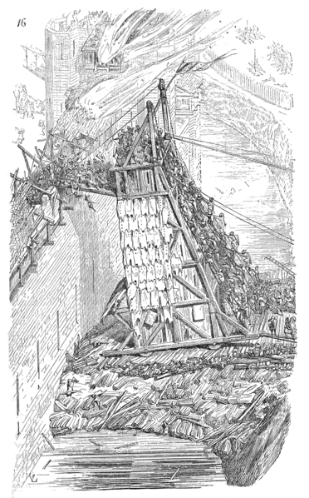
A siege tower is a specialized siege engine, constructed to protect assailants and ladders while approaching the defensive walls of a fortification. The tower was often rectangular with four wheels and a height roughly equal to that of the wall or sometimes higher to allow archers to stand on top of the tower and fire into the fortification.
The Helepolis was a particularly large type of siege tower.
Used throughout antiquity in both the Far East and Europe, siege towers were of unwieldy dimensions and therefore mostly constructed on site of the siege. Taking a lot of time to construct, siege towers were mainly constructed if the defense of the opposing fortification could not be overcome by ladder assault, by sapping or by breaking walls or gates.
The siege tower sometimes housed knights, or crossbowmen who shot arrows at the defenders. Because of the size of the tower it would often be the first target of cannons or any other heavy projectiles, but it had its own projectiles to fight back with.
Siege towers were sometimes used to enable troops to enter enemy fortifications. When a siege tower was near a wall, it would drop a gangplank between it and the wall. Troops could then rush onto the walls and into the castle or city.
4. Keep

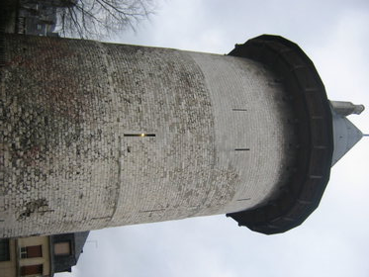
A tower house (or KEEP) is a particular type of stone dwelling, built for defensive purposes as well as habitation. Such buildings were built throughout Ireland, beginning in the middle ages and continuing at least up to the 17th century. The remains of such structures are dotted around the Irish countryside. Some are still intact and even inhabited today, while others stand as mere shells in a field.
Such buildings are often roughly classified as castles, as despite their diminutive size compared to a full castle, they are formidable habitations.

5. Fortress
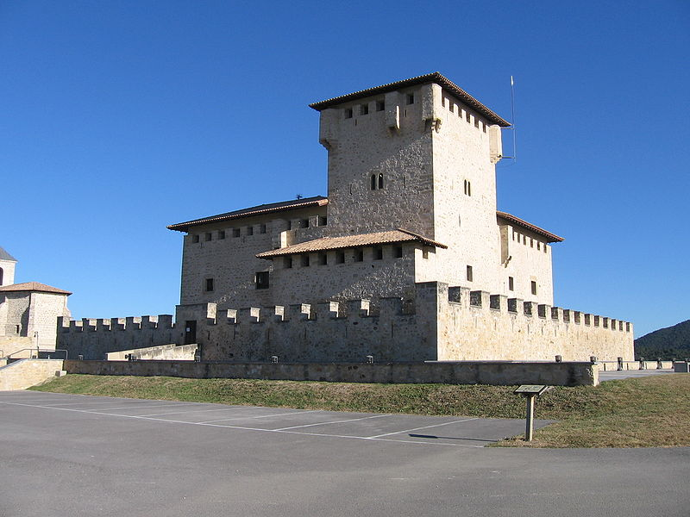
Fortifications are military constructions and buildings designed for defense in warfare. Humans have constructed defensive works for many thousands of years, in a variety of increasingly complex designs. The term is derived from the Latin fortis ("strong") and facere ("to make").
Many military installations are known as forts, although they are not always fortified. Larger forts may class as fortresses, smaller ones formerly often bore the name of fortalices. The word "fortification" can also refer to the practice of improving an area's defense with defensive works.
The art of laying out a military camp or constructing a fortification traditionally classes as castrametation, since the time of the Roman legions. The art/science of laying siege to a fortification and of destroying it has the popular name of siegecraft and the formal name of poliorcetics. In some texts this latter term also applies to the art of building a fortification.
Fortification is usually divided into two branches, namely permanent fortification and field fortification. Permanent fortifications are erected at leisure, with all the resources that a state can supply of constructive and mechanical skill, and are built of enduring materials. Field fortifications are extemporized by troops in the field, perhaps assisted by such local labor and tools as may be procurable, and with materials that do not require much preparation, such as earth, brushwood and light timber. There is also an intermediate branch known as semipermanent fortification. This is employed when in the course of a campaign it becomes desirable to protect some locality with the best imitation of permanent defences that can be made in a short time, ample resources and skilled civilian labor being available.
Medieval-style fortifications were largely made obsolete by the arrival of cannons on the 14th century battlefield. Fortifications in the age of black powder evolved into much lower structures with greater use of ditches and earth ramparts that would absorb and disperse the energy of cannon fire. Walls exposed to direct cannon fire were very vulnerable, so were sunk into ditches fronted by earth slopes. This placed a heavy emphasis on the geometry of the fortification to allow defensive cannonry interlocking fields of fire to cover all approaches to the lower and thus more vulnerable walls. Fortifications also extended in depth, with protected batteries for defensive cannonry, to allow them to engage attacking cannon to keep them at a distance and prevent them bearing directly on the vulnerable walls. The result was star shaped fortifications with tier upon tier of hornworks and bastions, of which Bourtange illustrated above is an excellent example. There are also extensive fortifications from this era in the Nordic states and in Britain, the fortifications of Berwick on Tweed being a fine example.
The arrival of explosive shells in the nineteenth century led to yet another stage in the evolution of fortification. Star forts of the cannon era did not fare well against the effects of high explosive, and the intricate arrangements of bastions, flanking batteries and the carefully constructed lines of fire for the defending cannon could be rapidly disrupted by explosive shells. Worse, the large open ditches surrounding forts of this type were an integral part of the defensive scheme, as was the covered way at the edge of the counter scarp. The ditch was extremely vulnerable to bombardment with explosive shells.
In response, military engineers evolved the polygonal style of fortification. The ditch became deep and vertically sided, cut directly into the native rock, layed out as a series of straight lines creating the central fortified area that gives this style of fortification its name.
Wide enough to be an impassable barrier for attacking troops, but narrow enough to be a difficult target for enemy shellfire, the ditch was swept by fire from defensive blockhouses set in the ditch as well as firing positions cut into the outer face of the ditch itself.
The profile of the fort became very low indeed, surrounded outside the ditch by a gently sloping open area so as to eliminate possible cover for enemy forces, while the fort itself provided a minimal target for enemy fire. The entrypoint became a sunken gatehouse in the inner face of the ditch, reached by a curving ramp that gave access to the gate via a rolling bridge that could be withdrawn into the gatehouse.
Much of the fort moved underground, with deep passages to connect the blockhouses and firing points in the ditch to the fort proper, with magazines and machine rooms deep under the surface.
The guns however were often mounted in open emplacements, simply protected by a parapet, both for a lower profile, and since experience with guns in closed casemates had seen them put out of action by rubble as their own casemates were collapsed around them.
Steel-and-concrete fortifications were common during the 19th and early 20th centuries, however the advances in modern warfare since World War I have made large-scale fortifications obsolete in most situations. Only underground bunkers are still able to provide some protection in modern wars. Many historical fortifications were demolished during the modern age, but a considerable number survive as popular tourist destinations and prominent local landmarks today.

6. Castle

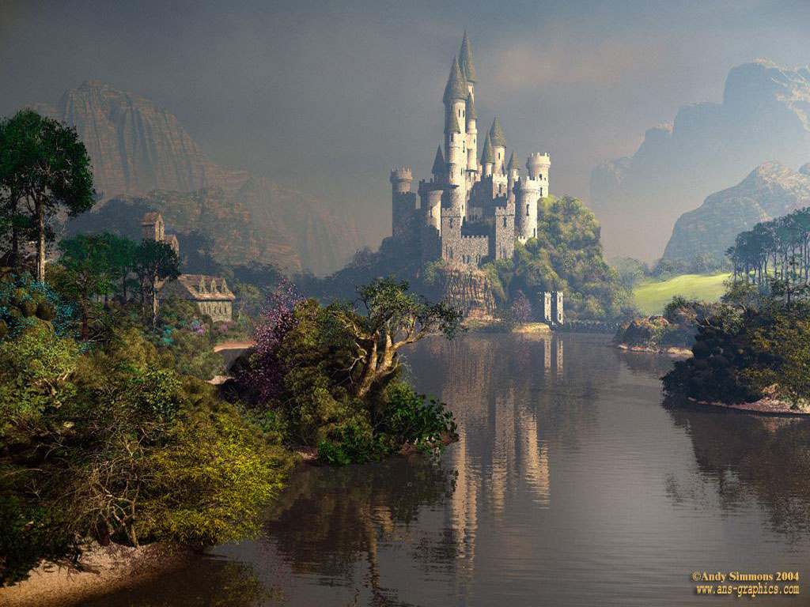
Castles were built not only as a defensive measure from hostile enemies, but as an offensive weapon. This article in general discusses castles as a defensive fortress, while this section examines the role of castles as an offensive weapon during the middle ages.
During the Middle Ages, in particular the High Middle Ages (the height of castle building in Europe), lords and kings often built castles for offensive reasons: territorial expansion and control of a region. A castle was a stronghold from which a lord or baron could control surrounding territory. The story of Hugh of Abbeville in the last decades of the 10th century illustrates this:
Because [Hugh of Abbeville's peers] were not all lords of castles, [he] became more powerful than the rest of his peers. For he could do what he liked without fear, relying on the protection of the castle, while others, if they tried anything, were easily overcome as they had no refuge.(Hariulf, Gesta ecclesiae Centulensis)
In the wake of the Norman Conquest, Norman lords constructed castles across England to control and conquer. During the Investiture Controversy in Germany during the 11th century, and the resulting decline of the German kingdom, castle building exploded as local warlords staked claims to minor kingdoms from behind newly-built castles. It is for this reason that so many castles were built throughout Europe: they were an offensive weapon that any warlord with ambitions could employ to control and conquer regional territory.

Castle building
The keep is the strong central tower of the castle. Castle building was a very common task as boundaries were pushed and territory conquered. The walls would most commonly go up first, so nothing could hurt the castle while it was being built. Then came the castle so the Town Lord could govern easily. Then a cathedral would be built. This would often be the longest job, due to the intricate artwork that went into it. Then the villagers would be left to build their houses and shops, often with a separate kitchen building. Fields would be built and crops harvested. A castle town is built.
Castles, on an average, took 10-15 years to complete. Nevertheless, this varied greatly since a castle built on top of a hill would generally take much longer to build that a castle situated on easy-to-build terrain.
As time passed, stronger castles were built. During the Middle Ages, a stronger need for security emerged; thus the building of concentric castles. Concentric castles took much longer to complete but they provided many lines of defense. Normally the outer wall would be finished first and then the rest; to protect the workers and the people already inhabiting the castle.
